SIMATS ENGINEERING

ASSESSMENT TOOL 1 (High)- C Code Prediction

COURSE NAME: Data Structures COURSE CODE:CSA03
COURSE OUTCOME COVERED

CO1: Basics, Data, Data object, Data structure, Abstract Data Types (ADT), realization of ADT in ‘C’, Primitive and non-primitive data structure, Linear and non-linear data structure Arrays & Recursion, Performance analysis and Measurement: Time and space analysis of algorithms, Average, best and worstcase analysis.
Assessment Tool Weightage: 30%

QUESTIONS:
Predict the Output – Variables and Data
#include <stdio.h>

int main() {
int a = 10, b = 20;
int c = a + b;
a = c - a;
b = c - b;

printf("%d %d %d", a, b, c);
return 0;
}
Question: Predict the output.

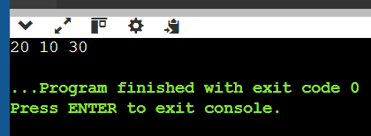

2. Predict the Output – Data Object
#include <stdio.h>

int main() {
int x = 5;
int y = x;

x = 10;

printf("%d %d", x, y);
return 0;
}
Question: Predict the output and explain why changing x does not change y.
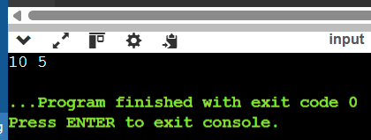

3. Predict the Output – Structure
#include <stdio.h>

struct Student {
int id;
float mark;
};

int main() {
struct Student s = {101, 85.5};

printf("%d %.1f", s.id, s.mark);

return 0;
}
Question: Predict the output and identify the data object created by the declaration.
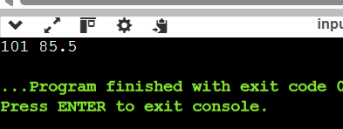

B. Primitive and Non-Primitive Data Structures
4. Predict the Output – Array
#include <stdio.h>

int main() {
int a[5] = {10, 20, 30, 40, 50};

printf("%d %d %d",
a[0], a[2], a[4]);

return 0;
}

Question: Predict the output.
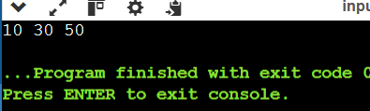

5. Predict the Output – Character Array
#include <stdio.h>

int main() {
char str[] = "DATA";

printf("%c %c %c",
str[0], str[2], str[3]);

return 0;
}
Question: Predict the output and identify the type of data structure represented by str.
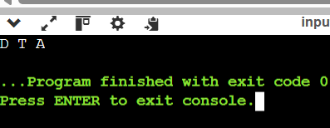

C. Linear Data Structures – Arrays
6. Trace the Array Modification
#include <stdio.h>

int main() {
int a[5] = {2, 4, 6, 8, 10};

for(int i = 0; i < 5; i++)
a[i] = a[i] + i;

for(int i = 0; i < 5; i++)
printf("%d ", a[i]);

return 0;
}
Question: Predict the final output.
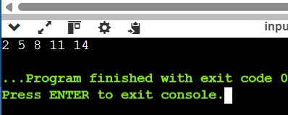

7. Predict the Output – Reverse Array
#include <stdio.h>

int main() {
int a[] = {1, 2, 3, 4, 5};

for(int i = 0; i < 5/2; i++) {
int temp = a[i];
a[i] = a[4-i];
a[4-i] = temp;
}

for(int i = 0; i < 5; i++)
printf("%d ", a[i]);

return 0;
}
Question: Predict the output.
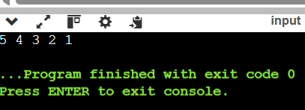

8. Predict the Output – Array Sum
#include <stdio.h>

int main() {
int a[] = {5, 10, 15, 20};
int sum = 0;

for(int i = 0; i < 4; i++) {
sum += a[i];
}

printf("%d", sum);

return 0;
}
Question: Predict the output and determine the time complexity.
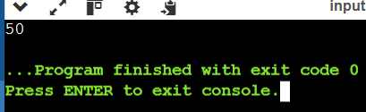

9. Predict the Output – Two-Dimensional Array
#include <stdio.h>

int main() {
int a[2][3] = {
{1, 2, 3},
{4, 5, 6}
};

printf("%d %d %d",
a[0][2],
a[1][0],
a[1][2]);

return 0;
}
Question: Predict the output.
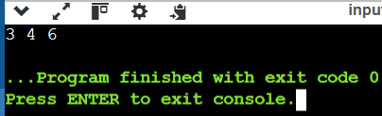

10. Predict the Output – Matrix Processing
#include <stdio.h>

int main() {
int a[2][2] = {{1, 2}, {3, 4}};
int sum = 0;

for(int i = 0; i < 2; i++)
for(int j = 0; j < 2; j++)
sum += a[i][j];

printf("%d", sum);

return 0;
}
Question: Predict the output and determine the time complexity.
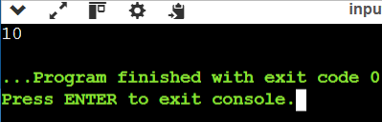

D. Abstract Data Types (ADT)
11. Predict the Output – Stack ADT Concept
#include <stdio.h>

#define SIZE 5

int stack[SIZE];
int top = -1;

void push(int x) {
stack[++top] = x;
}

int pop() {
return stack[top--];
}

int main() {
push(10);
push(20);
push(30);

printf("%d ", pop());
printf("%d ", pop());

return 0;
}
Question: Predict the output and identify the ADT operation being performed. 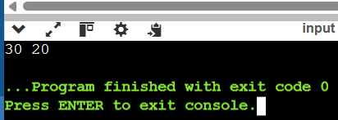

12. Predict the Output – Queue ADT Concept
#include <stdio.h>

#define SIZE 5

int queue[SIZE];
int front = 0, rear = -1;

void enqueue(int x) {
queue[++rear] = x;
}

int dequeue() {
return queue[front++];
}

int main() {
enqueue(10);
enqueue(20);
enqueue(30);

printf("%d ", dequeue());
printf("%d ", dequeue());

return 0;
}
Question: Predict the output and identify the principle followed by the ADT. 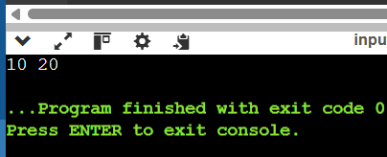
13. Predict the Output – ADT Using Structure
#include <stdio.h>

struct Stack {
int data[3];
int top;
};

int main() {
struct Stack s = {{10, 20, 30}, 2};

printf("%d", s.data[s.top]);

return 0;
}
Question: Predict the output and identify the current top element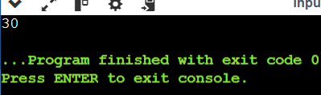.

E. Recursion
14. Predict the Output – Simple Recursion
#include <stdio.h>

void fun(int n) {
if(n == 0)
return;

printf("%d ", n);
fun(n - 1);
}

int main() {
fun(5);
return 0;
}
Question: Predict the output.
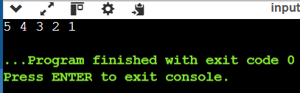

15. Predict the Output – Reverse Recursion
#include <stdio.h>

void fun(int n) {
if(n == 0)
return;

fun(n - 1);
printf("%d ", n);
}

int main() {
fun(5);
return 0;
}
Question: Predict the output. How is this different from Question 14?
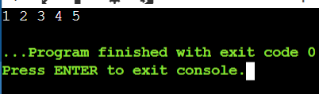

Code of Conduct:

I ____________________ (Name / Reg No) certify that this submission is my original work and that I have adhered to the guidelines specified for this assessment.
I understand that any violation of academic integrity rules will result in disciplinary action.

Signature of the student:
RUBRICS FOR CALCULATION:
Numerical Problems

Criteria | Weightage | Level 4 (Exemplary) | Level 3 (Proficient) | Level 2 (Developing) | Level 1 (Beginning)
Problem Understanding | 20% | Clearly interprets problem, identifies all parameters and requirements accurately | Understands problem with minor gaps | Partial understanding; misses key elements | Misinterprets or unable to understand problem
Method Selection | 20% | Selects most appropriate method/formula with strong justification | Selects correct method with minor errors | Inappropriate or partially correct method | Unable to select method
Solution Process | 25% | Logical, systematic steps with correct approach throughout | Mostly correct steps with minor mistakes | Disorganized steps; multiple errors | No clear process
Accuracy of Calculation | 20% | All calculations accurate; correct final answer | Minor calculation errors | Frequent errors; incorrect final answer | No valid calculations
Interpretation of Results | 15% | Clearly interprets results with units and engineering relevance | Basic interpretation with minor omissions | Limited or unclear interpretation | No interpretation

